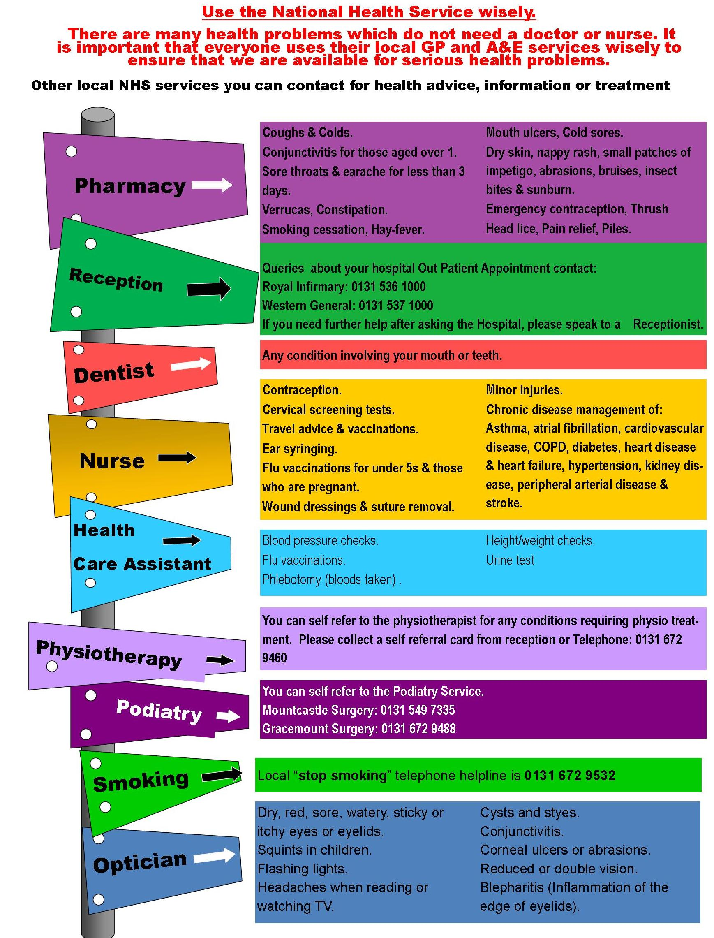

Visit your local Pharmacy or telephone your local smoking cessation hotline on 0800 028 5208 or 0141 232 4581

**Podiatry new patient appointments can be made by contacting the Referral Management Centre on 0141 347 8909 – Monday to Friday 8am – 8pm and Saturday 9am – 1pm. Alternatively you can email AHP.Appointments@ggc.scot.nhs.uk**

**You can self refer to the Physiotherapist for any condition requiring physio treatment. Please collect a self referral form from Reception at the Surgery.**

**Queries about your hospital outpatient appointment, contact:**

**Queen Elizabeth 0141 201 1100**

**Victoria Infirmary 0141 201 6000**

**To make an appointment with the GP/Nurse or Health Care Assistant contact Practice reception**

**Contraception – injection/tablet Chronic Disease Management of**

**/implants/advice Asthma, Atrial Fibrillatio, Cardio**

**Cervical Screening tests vascular disease, COPD,**

**Travel advice and vaccinations Diabetes, Heart Disease and**

**Ear syringing Heart Failure, Hypertension,**

**Flu vaccinations Kidney Disease, Peripheral**

**Minor injuries Arterial Disease and Stroke**

**Blood pressure checks Height/weight checks**

**Flu vaccinations New Patient checks**

**Phlebotomy (blood taken) Urinalysis**